EXPERIMENT -13
Hypothetical using T-Test
Aim:
To test whether the average IQ score of a sample of students differs significantly from a
population mean IQ score of 100

Procedure:
1. Null hypothesis
2. Alternative hypothesis
3. Sample
4. Z-Test
5. Decision Rule

Program:
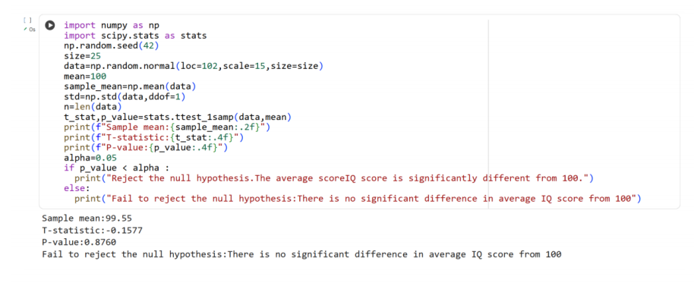
Result:
Thus the python program for hypothetical test using T-Test is executed and output is
verified successfully

